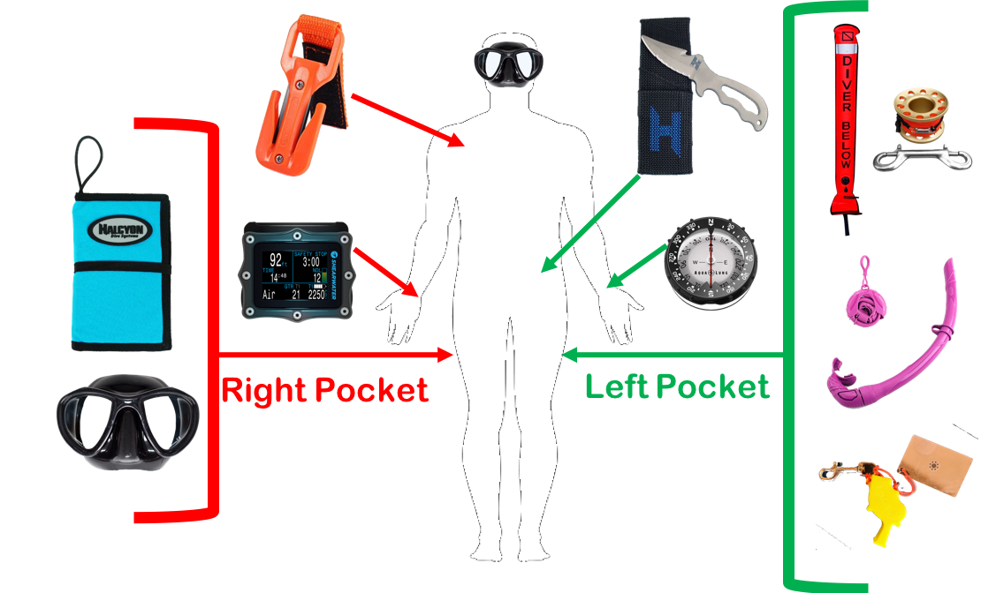

Required Equipment for Advanced Training:

* Tech Shorts or Pockets
* Wetnotes/Pencil
* Primary Dive Light
* Backup Dive Light
* Dive Computer
* 2 Cutting Tools
* SMB w/Spool & Double-End Bolt Snap
* Diver Marker Light (Flashing Light)
* “Working” Double-End Bolt Snap
* Optional: Spare mask, collapsible snorkel, rescue aids